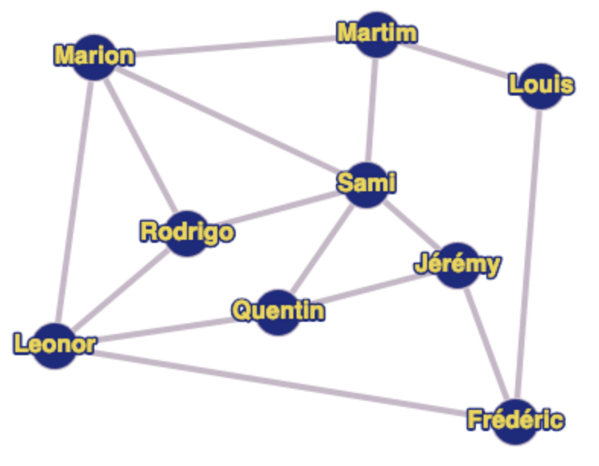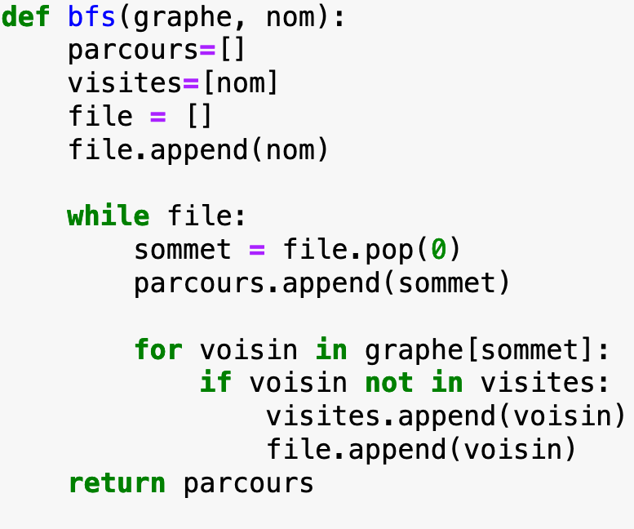

File:

|  |  |  |  |  |  |  |  |  |
| --- | --- | --- | --- | --- | --- | --- | --- | --- |
| Louis |  |  |  |  |  |  |  |  |

Parcours:

|  |  |  |  |  |  |  |  |  |
| --- | --- | --- | --- | --- | --- | --- | --- | --- |
|  |  |  |  |  |  |  |  |  |

